**Annual Report**

**Department of History**

In the previous year (2020-21) Department of History organised several activities in the college.

* A study trip to the National Museum (Delhi) was conducted for B.A. (Prog.) students, specifically for the coursework of Ancient Indian History – ‘History of India, c. 300-1200’, on 11 Feb. 2020, by the faculty members Dr. Shambhu Singh Yadav and Mr. Pankaj Bahot.
* History society (Yugabd) organised virtual audition to select new volunteers and added 13 new members in the team of History Society (26 Jan. 2021).
* History Department organised Orientation program on 26 Feb. 2021, for the interaction between students, members of the society and Faculty members.
* Ms. Charu Mittal and Dr. Shambhu Singh Yadav (Faculty members, Department of history) gave interview to one of the YouTube channel on “How to Write answers in OBE” (3RD March 2021). Link- <https://youtu.be/bCdckVCYrE>
* In the guidance of teacher Incharge (Sh. Sheo Dutt), the Society of History department (***Yugabd***) conducted a webinar (Lecture) entitled ‘**Everyday Lives in Early Medieval India**’ by the eminent Historian and Professor (University of Delhi)- Prof. **B.P. Sahu,** on 22 April 2021. It was a wonderful webinar and great number of students and faculty members participated in this webinar. We are very glad that our principal Prof. S.K. Sinha, helped us a lot to organise this webinar and very actively he participated in the lecture. We (The History Department) looking forward for more activities like this in future with the help of our teacher Incharge Sh. Sheo Dutt and Principal Prof. S.K. Sinha.

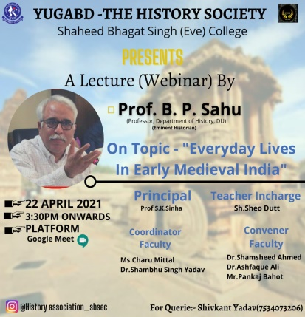 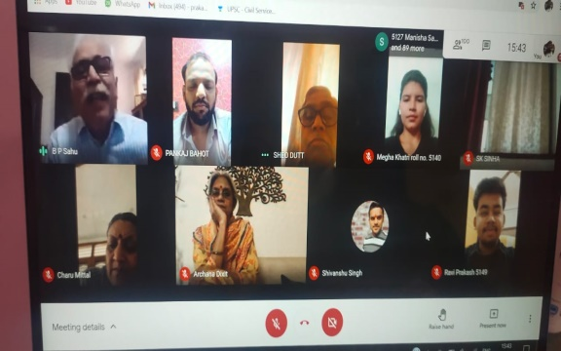 (Picture of Webinar)

(Poster of Webinar )

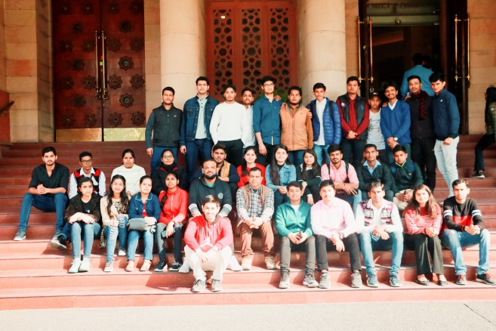 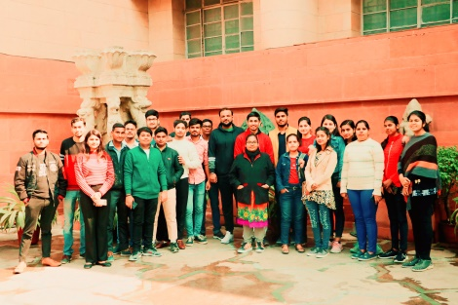

(Visit at National Museum) Picture:1 (Visit at National Museum) Picture:2